“Київський фаховий коледж зв’язку”

Циклова комісія Комп’ютерної інженерії

**ЗВІТ ПО ВИКОНАННЮ**

**ЛАБОРАТОРНОЇ РОБОТИ №1**

з дисципліни: «Операційні системи»

**Тема: “ Ознайомлення з робочим середовищем віртуальних машин та операційних систем різних сімейств ”**

Виконали студенти

групи КСМ-13а

Команда “Viper”:

Малієнко А. М.,

Мішин А. О.

та Нерощин Д.О.

Перевірив викладач

Сушанова В.С.

Kyiv 2023

Topic: "Linux Commands for Process Management"

The goal of the work:

1. Getting practical skills for working with the Bash command shell.

2. Familiarity with basic commands for process management.

Material provision of classes

1. IBM PC type computer.

2. OS family Windows (Windows 7).

3. Virtual machine - Virtual Box (Oracle).

4. GNU/Linux operating system - CentOS.

5. Cisco network academy site netacad.com and its online Linux courses

A. O. Malienko prepared the report.

Tasks for preliminary preparation.

1. Command (Command) - An instruction that you enter in the command line to perform a certain action.

Parameter - Additional information that you specify with the command to configure its behavior. Parameters are usually specified after the command and can be named or positional.

Option - This is an optional command parameter that is usually included with a specific flag or keyword. Options allow you to customize the command's behavior.

Argument - Information provided as input to a command or function. Arguments can be mandatory or optional.

Syntax - The rules and structure by which commands and their parameters must be entered for correct execution.

Execute - Execution of a command or program to perform a specific operation.

Output - The result of the execution of a command or program, which is displayed on the screen or written to a file.

Input - Input data that comes to a command or program for processing.

Pipe (Channel) - A mechanism that allows the output of one command to be passed as input to another command.

Redirect - The process of changing the direction of the output or input of a command, such as writing output to a file or reading data from a file.

basic English terms for command assignments and their parameters.

2.

Ps - This command allows you to display information about active processes. You can browse the possible options using options such as -aux to list all processes or -e to list all processes.

Top - This command provides interactive monitoring of the state of processes in real time. You can view parameters, sort processes and see their activity.

2.2. No, the ps command does not monitor the state of processes in real time. It provides a report on the state of the processes at the time when the ps command is executed.

2.3. In the top command, it is possible to sort processes by various parameters, such as CPU, memory, execution time, etc. You can use the following keys to sort processes:

P - Sort by CPU from highest to lowest.

M - Sort by memory from highest to lowest.

T - Sort by execution time from highest to lowest.

To switch between different sorting options, simply press the appropriate key when using the top command.

2.4. Commands to terminate processes include:

Kill - This command is used to kill processes by specifying their process ID (PID).

Pkill - This command allows you to kill processes by their name or other attributes.

Killall - This command kills all processes with the specified name.

3. Ctrl + C - Stop the current command or process.

Ctrl + D - Quit the current terminal or end typing in the terminal.

Ctrl + Z - Move the current process to background mode.

"Find out what processes are running in the background on Linux" (Find out what processes are running in the background on Linux), you can use the jobs command to view the list of processes running in the background in the current terminal.

Student A. Mishin prepared the material.

Progress.

1. Initial work in CLI mode in Linux OS of the Linux family:

1.1. Start the VirtualBox virtual machine, select CentOS and run it. Log in

under user: CentOS, password for login: reverse (if you run LR in 401 aud.) and run

terminal.

1.2. Start the Ubuntu_PC virtual machine (if you are doing the LR tasks through the netacad academy)

1.3. Start your Linux family operating system (if you are working on your own PC and its

installed) and launch the terminal.

2. Answer the following questions:

- How to display the contents of the /proc directory? Where is it located and what is it for?

Describe the information about its content?

The /proc directory is located in the root directory of the Linux file system and is intended to provide information about running processes and kernel options. To display its contents, use the ls /proc command. The contents of this directory contain information about processes, system resources, kernel settings, and more.

- How to display information about current user sessions. What team can do this?

To display information about current user sessions, use the who command. It will show a list of active user sessions, along with their login names, dates, and login times.

- What actions can be done in the terminal using the Ctrl + C, Ctrl + D and Ctrl + Z combinations?

Ctrl + C: Sends an INT signal to the active process  
**Ctrl + D - Quit the current terminal or end typing in the terminal.**

**Ctrl + Z - Move the current process to background mode.**

**"Find out what processes are running in the background on Linux" (Find out what processes are running in the background on Linux), you can use the jobs command to view the list of processes running in the background in the current terminal.**

**Student A. Mishin prepared the material.**

**Progress.**

**1. Initial work in CLI mode in Linux OS of the Linux family:**

**1.1. Start the VirtualBox virtual machine, select CentOS and run it. Log in**

**under user: CentOS, password for login: reverse (if you run LR in 401 aud.) and run**

**terminal.**

**1.2. Start the Ubuntu_PC virtual machine (if you are doing the LR tasks through the netacad academy)**

**1.3. Start your Linux family operating system (if you are working on your own PC and its**

**installed) and launch the terminal.**

**2. Answer the following questions:**

**- How to display the contents of the /proc directory? Where is it located and what is it for?**

**Describe the information about its content?**

**The /proc directory is located in the root directory of the Linux file system and is intended to provide information about running processes and kernel options. To display its contents, use the ls /proc command. The contents of this directory contain information about processes, system resources, kernel settings, and more.**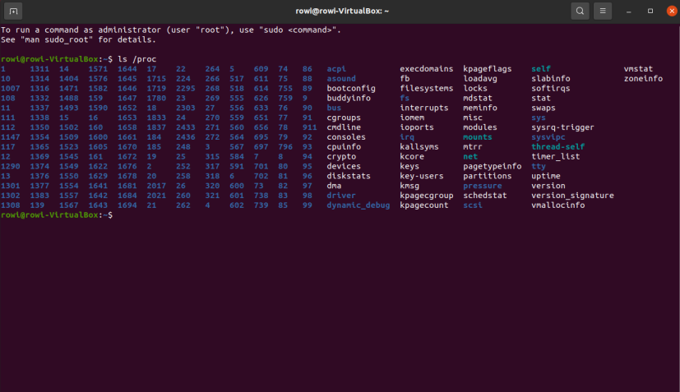

- How to display information about current user sessions. What team can do this?

To display information about current user sessions, use the who command. It will show a list of active user sessions, along with their login names, dates, and login times.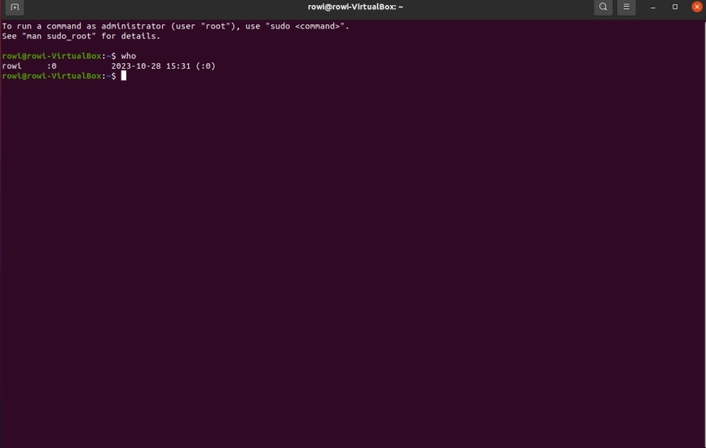

- What actions can be done in the terminal using the Ctrl + C, Ctrl + D and Ctrl + Z combinations?

Ctrl + C: Sends an INT signal to the active process, causing it to terminate.

Ctrl + D: Used for EOF signal in interactive mode. For example, this can be used to complete keyboard input.

Ctrl + Z: Suspends the current process and puts it in the background.

- How is the background process different from the usual one. Where are they used?

A background process is a process that runs in the background and does not block the terminal. It can continue to run even when you close the terminal or log out. Normal processes run in active mode and await user input.

- Describe the following commands and explain what they do – the jobs, bg, fg command.

jobs: Lists all current background jobs in the current terminal session, along with their IDs.

bg: Makes a background task active so that it continues to run in the background.

fg: Makes a background task active and active in the current terminal.

- Which command can be used to view information about background processes launched in the system and

tasks?

Information about background processes and tasks running in the system can be viewed using the jobs command

- How to suspend the background process, how to restore it later and, if necessary, restart it?

To stop a background process, use the kill -STOP PID command, where PID is the process ID. Then, to resume its execution, use the kill -CONT PID command. If you need to restart a background process, you can use the bg or fg commands to make it active and run or continue in the background.

3. Start the terminal, and in the command line, perform the following actions to familiarize yourself with working with

processes:

- run the top command, analyze the result obtained in this command and characterize it

the most active processes in the system;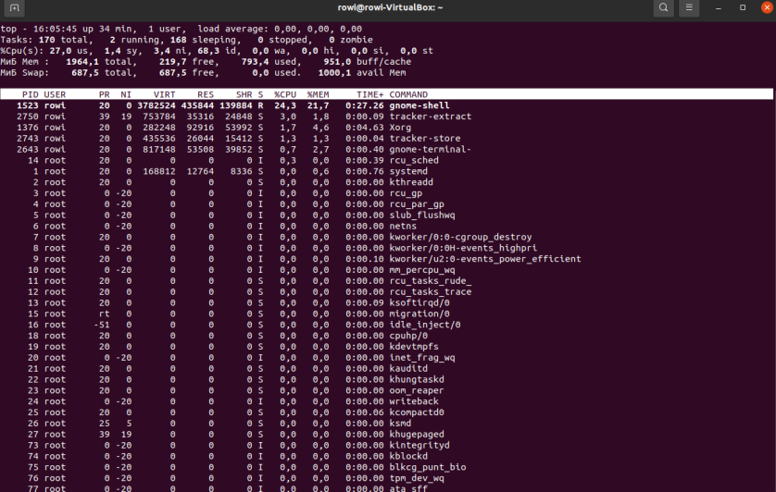

The most active processes are gnome-shell, gnome-terminal, Xorg

- suspend execution of the top command (key combination must be used);

To stop the execution of the top command, use the keyboard shortcut Ctrl + C

- display information about processes using the ps command;

To display information about processes using the ps command, enter the ps command in a terminal. It will display a list of processes for the current user

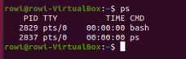

- give 5 examples using different parameters of the ps command (for example, output only

system processes, display the processes of a specific user, display the process tree, etc.).

Describe exactly what your chosen parameters dops

ps aux: Lists all processes for all users in an extended format, including information ab

out CPU, memory, and more.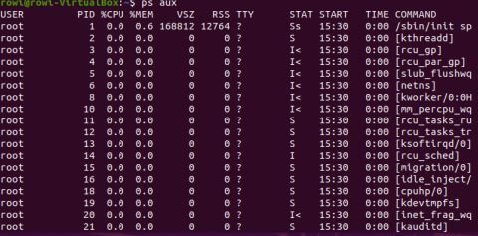

ps -e: Виводить усі процеси в системі.

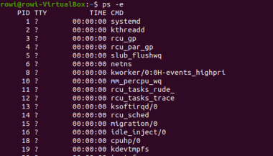

ps -u username: Виводить процеси, які належать певному користувачеві, де username - ім'я користувача.

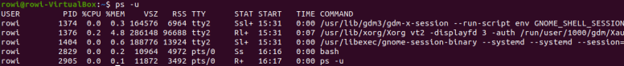

ps -axjf: Виводить дерево процесів (у вигляді структури дерева), разом із залежностями між ними.

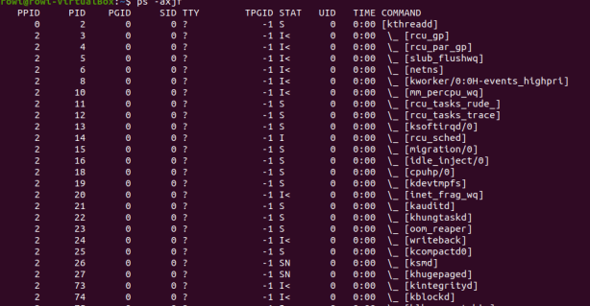

- check if you have running background processes, which ones?

- resume the execution of the suspended background process initially in the position "in the foreground

in the foreground" (foreground), then pause it once again, and then resume its execution in the position

"in the background" (background)

- end this background process

To check if background processes are running, use the jobs command. It will show a list of active background tasks in the current terminal session. To resume execution of a suspended background process initially in the "foreground" position, use the fg command. To pause it again, use Ctrl + Z, then resume it in the "background" position with the bg command. To kill a background process, use the kill PID command, where PID is the ID of the background process you want to kill

Student D. O. Neroshchyn prepared the material.

Control questions

1) The /proc directory on Linux systems contains a virtual file system that provides access to information about various system resources, processes, and kernel statistics. It stores information about processes, information about the kernel, resources used by processes, and many other system information.

2) To determine which of the three processes is using the most memory, you can use the ps command with the -o rss (resident set size) option to display the amount of memory each process is using. Then you can sort the results by size and choose the largest amount of memory. The percentage of memory consumed by this process can be calculated by comparing its size with the total amount of available memory.

3) To get the parent process hierarchy on Linux systems, you can use the pstree command, which displays a tree of processes and their dependencies. This hierarchy shows which processes are parents of other processes in the system.

4) The command top and ps are tools for monitoring system resources and processes in the system. The main difference is that top provides real-time interactive monitoring where you can see the information update in real-time, while ps provides point-in-time reporting at the time the command is executed.

5) htop is an interactive process monitor that provides additional capabilities compared to top. It allows you to interactively sort and filter the list of processes, shows information about resources, displays graphs of CPU and memory usage, and allows you to interact with processes, such as terminating them.

6) Components of a mobile operating system for monitoring running processes may include a system monitor that provides information about resource usage and processes, as well as the ability to monitor battery consumption, network activity, and other parameters.

7) Many mobile operating systems support terminal management of processes through the command line or additional programs. For example, in Android, you can use the terminal or third-party applications to manage and monitor processes.

8) Yes, you can install third-party applications to manage and monitor processes on your mobile phone. For example, there are many applications for Android, such as "Task Manager" or "Advanced Task Killer," which allow you to terminate processes, monitor memory usage, and other parameters. iOS also has apps that help monitor and manage processes.